Airspeed Sensor and Segway into CAN

Contents

1 Links 2

2 CAN Protocol 2

2.1 Resources 2

2.2 Hardware 3

2.3 CAN Message Packet 3

2.4 Frames 4

3 Implementation 4

3.1 Libraries 4

3.2 Proof of Concept 5

3.3 Air Speed Sensor Integration Ideas 5

4 Pressure Transducer 6

5 Sensor SPI Interface 8

5.1 Payload description 9

6 TODOs 10

# Overview

The purpose of this document is to document research and progress on the advance plane airspeed sensor implementation.

The purpose of the airspeed sensor is to provide airspeed data for ADV mechanical teams for post flight analysis. The previous sensor in year 2023/2024 was mounted on the tail and ran a long I2C harness all the way to the sensors board sitting in the fuselage. I2C is known for its sensitivity to long harness lines.

The solution to this problem is to switch the interface between the airspeed sensor and sensors board to CAN instead of I2C. CAN is known to be reliable with long harness runs and is a well-known industry standard protocol. As well, this will be the first CAN project in Sensors and Comms, which can open a gateway to possibly transitioning to adopting more CAN communications in future revisions.

The document includes CAN research, airspeed sensor calibration, and some quick notes!

# Links

[Diagnosing CAN Bus Communication Problems](https://www.orionbms.com/general/diagnosing-canbus-communication-problems/)

# CAN Protocol

## Resources

Generic top level CAN explanations, good introductions.

[CAN Protocol Explained](https://www.youtube.com/watch?v=WikQ5n1QXQs)

[CAN Bus: A Beginner’s Guide](https://www.youtube.com/watch?v=YBrU_eZM110)

[The CAN Bus Protocol Tutorial](https://kvaser.com/can-protocol-tutorial/)

## Hardware

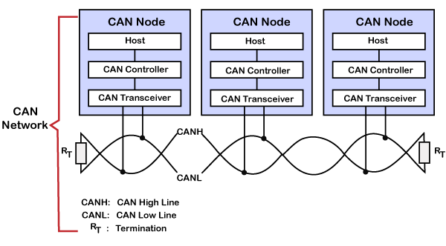

*Figure 1*

Rt: 120 Ohm termination resistors to match the impedance of a differential pair (bit transfer functionality and limits bit reflections on the line). 120 Ohm parallel equates to 60 Ohms series.

Bits: 1-recessive, 0-dominant. Bit recessive/dominant description is a consequence of the 120 Ohm termination resistors.

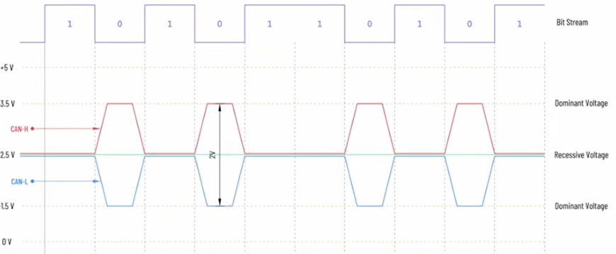

*Figure 2*

Noise: Differential pairing resolves common noise. There are recommended [cable/stub lengths](https://www.buenoptic.net/encyclopedia/item/537-maximum-cable-length-for-a-can-bus.html).

## CAN Message Packet

*Figure 3: CAN Packet*

SOF (start of frame): dominant zero

11-bit identifier: unique ID for each message. Message IDs with lower value are higher priority (relates to 0-dominant transmission functionality) in the bus arbitration assignment. “0” overpowers a “1” bit.

*Figure 4*

CAN network can be configured to work with two different message (or frame) formats: standard/base frame format (CAN 2.0 A and CAN 2.0 B) or the extended frame format (described only by a CAN 2.0 B).

* Base/Standard: supports a length of 11 bits for the identifier
* Extended: supports length 29 bits for the identifier. Extension to allow more message types to occupy a network.

## Frames

CAN has four frames:

1. Data: node data for transmission
2. Remote: Requesting the transmission of a specific identifier
3. Error: transmitted by any node detecting an error
4. Inject delay between data or remote frame

Data frame is the most commonly used.

# Implementation

## Libraries

For Arduino-STM32: <https://github.com/nopnop2002/Arduino-STM32-CAN>

## Proof of Concept

* Basic CAN communication between two uC established, integrated library

*Figure 5*

## Air Speed Sensor Integration Ideas

CAN bridge between airspeed sensor and main sensors/comms central uC.

*Figure 6*

Transmission:

Idea 1: CAN Bridge uC transmits airspeed sensor data (outputs data frame) periodically on an autonomous basis to the main sensors uC.

* Biased towards this idea first

Idea 2: Main Sensors uC periodically retrieves airspeed sensor data (request-response)

* Main Sensors uC sends a remote frame to CANBridge uC and CAN Bridge uC responds with most recent air speed sensor data
* This would be useful to save data logging space, don’t need to log airspeed when plane is not flying. Mechanical team interested in the maximum speed of the plane.

# Pressure Transducer

Exact part number: [4525DO-TP5AS005GPF](https://www.te.com/en/product-4525DO-TP5AS005GPF.html)

Sensor order breakdown:

* Package Type: Dual Sideport
* Supply Voltage: 3v3 Vdc
* Output Type: B 🡪 5% to 95%
* Interface Type: I2C (addr. 0x46H)
* Pressure Range (psi): 001
* Pressure Type: Differential A close-up of a text

  Description automatically generated

*Figure 7*

Transducer readings output gauge pressure. Variations in altitude and temperature will affect pressure.

*Figure 8*

*Figure 9*

## Calibration

Wind tunnel testing was conducted to calibrate the airspeed sensor.

### August 17th

A series of data points were collected to compare airspeed readings from the wind tunnel and the sensor. Airspeed readings were incremented at 50 RPM and the Pitot tube was mounted parallel to laminar flow.

*Figure 10: Airspeed readings from wind tunnel and sensor (trial)*

The reading comparisons show that the deviation between airspeed readings from the wind tunnel and sensor increases as the wind speed in the tunnel increases.

This wind tunnel test was a trial run. The Pitot tube was mounted to the thrust stand with tape and therefore was sensitive to vibrations at higher windspeeds hence the increasing error.

### August 31st

The same procedure was performed in the wind tunnel with a revised mount for the Pitot tube to eliminate the sensitivity of vibrations at high windspeeds. Please see figure 12 capturing the revised mounting setup.

*Figure 11: Airspeed readings from wind tunnel and sensor (improved mounting)*

With this improved setup, the reading comparisons show that the deviation between airspeed readings from the wind tunnel and sensor decreases as the wind speed in the tunnel increases. It appears that the sensor requires some adjustment for airspeeds under 18m/s. The two readings converge for wind speeds 18m/s and above.

Assuming that the wind tunnel readings represent the true value (reference) of airspeed, the sensor’s accuracy performance is accurate within 2% for wind speeds above 18m/s and can be inaccurate up to 80% for very low wind speeds (i.e. 4->8m/s). This is the sensor reading performance with no accuracy adjustments. This statement only holds true if the Pitot tube is mounted parallel to laminar flow.

*Figure 12: Pitot tube wind tunnel setup*

# Sensor SPI Interface

[Interfacing to MEAS Digital Pressure Modules](https://www.amsys.de/downloads/notes/I2C-Interface-to-Digital-Pressure-Sensors-AMSYS-an802e.pdf)

[Application Note](https://www.te.com/commerce/DocumentDelivery/DDEController?Action=showdoc&DocId=Specification+Or+Standard%7FMS45xx_Application_Note%7FA1%7Fpdf%7FEnglish%7FENG_SS_MS45xx_Application_Note_A1.pdf%7FCAT-BLPS0041)

[Configuration, POR and Power Consumption](https://www.amsys-sensor.com/downloads/notes/Configuration-POR-and-Power-Consumption-AMSYS-an801e.pdf)

## Payload description

Data resolution: 14-bit pressure, 11-bit temperature

*Figure 11*

Status bits

*Figure 12*

* Implement flags, carry out with enums

# PCB

Comin soon 😊

# TODOs

* EMI test with motor and scope noise
* Integrated [Air Speed Sensor](https://rcdrone.top/products/pixhawk-px4-digital-airspeed-sensor-kit-differential-pitot-pitot-tube-air-speed-meter-for-pixhawk-autopilot-flight-controller?currency=USD&variant=44909919600864&utm_source=google&utm_medium=cpc&utm_campaign=Google%20Shopping&stkn=677f40c1dee9&gad_source=1&gclid=CjwKCAjwnK60BhA9EiwAmpHZw_iOQeMVey3sYSjgu3k655pOZhKnLSx8fwthNrIM7Hm9aGpOPE_JshoCwboQAvD_BwE)
  + [MS4525DO](https://www.te.com/commerce/DocumentDelivery/DDEController?Action=showdoc&DocId=Data+Sheet%7FMS4525DO%7FB10%7Fpdf%7FEnglish%7FENG_DS_MS4525DO_B10.pdf%7FCAT-BLPS0002)
  + [MS4515](https://www.te.com/commerce/DocumentDelivery/DDEController?Action=showdoc&DocId=Data+Sheet%7FMS4515%7FB8%7Fpdf%7FEnglish%7FENG_DS_MS4515_B8.pdf%7FCAT-BLPS0040)
* [Air velocity and flow measurement using a Pitot tube](https://www.sciencedirect.com/science/article/pii/S0019057898000366)
* [Flight Mechanics for Pilots](https://agodemar.github.io/FlightMechanics4Pilots/mypages/airspeeds/)
* Clarify the maximum expected airspeed of plane. Needed to determine calibration formula.
* Formalized wind tunnel with mount on aug31st?
* Start pcb?
* Start defining payload CAN

July 27, 2024

* Clarified pressure transducer functionality
* Research airspeed calculation. Can we incorporate temperature into the calculation to improve accuracy?
* Plan wind tunnel schedule.